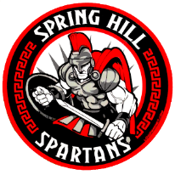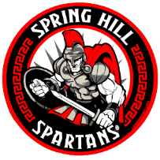

**Spring Hill Middle School**

**22801 Airbase Road**

**Laurinburg, NC 28352**

**(910) 369-0590**

October 25, 2023

Dear Spartan Family:

I hope the school year has started successfully for all of you. As you are aware, Spring Hill Middle did not make growth for the 2022-2023 school year and we are aggressively addressing this to see improvements for the 2023-2024 school year. We have also been designated as a Targeted Support & Improvement - Additional Targeted Support (TSI-AT) school by the North Carolina State Board of Education. As stated in ESSA Section 1111(d)(2), North Carolina had to identify schools for targeted support and improvement. TSI-AT schools in North Carolina are those that have a subgroup that is under-performing. The intent of this opportunity is to improve educational outcomes for all students, close achievement gaps, increase equity, and improve the quality of instruction. As a TSI-AT school, Spring Hill Middle School is required to develop a comprehensive plan that specifically addresses how we will improve student achievement. The plan is detailed below…

**We have set the following goals forSpring Hill Middle School this year:**

* By June 2024, SHMS will obtain a 10% increase in proficiency in Math and Reading Achievement to include 6th - 8th grades.
* By June 2024, SHMS will reduce the number of OFFICE DISCIPLINE REFERRALS (ODRs) by 20% school-wide.
* By June 2024, SHMS will reduce the teacher turnover rate by 10% in order to maintain a well-trained and dedicated staff.
* By June 2024, SHMS will increase our SWD subgroup by 10%.

**We continue to focus on individual subgroups to ensure ALL groups make growth. Below is an outline of supports and interventions that will be implemented to support our students for the 2023-2024 school year.**

* Develop and implement a School Improvement Plan that addresses whole school and individual subgroup deficits to support learning and growth.
* Implement targeted interventions through FLEX Time which includes small groups and specific work to address deficits 2 x per day.
* Create and utilize NEW MTSS (Multi-Tiered System of Support) Interventionist position to oversee the MTSS process
* Utilize NEW Math & Reading Curriculum for alignment and engagement.
* Host Parent Nights to inform parents of resources available to support student learning

**Parent engagement is a key component in student success. Here are some ways we can work together.**

* Know the content your student will learn for this year (<https://www.dpi.nc.gov/districts-schools/classroom-resources/academic-standards/standard-course-study>)
* Make sure that your student is prepared and attends school each day.
* Monitor your student’s progress using the PowerSchool Parent Portal.  See the front office for information.
* Monitor your student’s homework and keep track of our social media sites (webpage/Facebook)
* Attend meetings to plan and implement strategies to ensure your child’s success

**Preparing our students is much easier when we work together. Here are some resources available to help:**

* Graduation requirements: [www.ncpublicschools.org/gradrequirements/](http://www.ncpublicschools.org/gradrequirements/)
* K-12 standards in academic subjects: [www.ncpublicschools.org/curriculum/](http://www.ncpublicschools.org/curriculum/)
* State student achievement test results: [www.ncpublicschools.org/accountability/](http://www.ncpublicschools.org/accountability/)
* N.C.School Report Cards: <https://ncreportcards.ondemand.sas.com/src>

We are excited about the possibilities this school year and our partnership to ensure success for all students. If you have questions or concerns, please contact our school.

Sincerely,

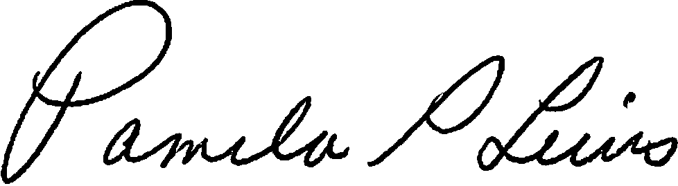

Pam Lewis, Principal